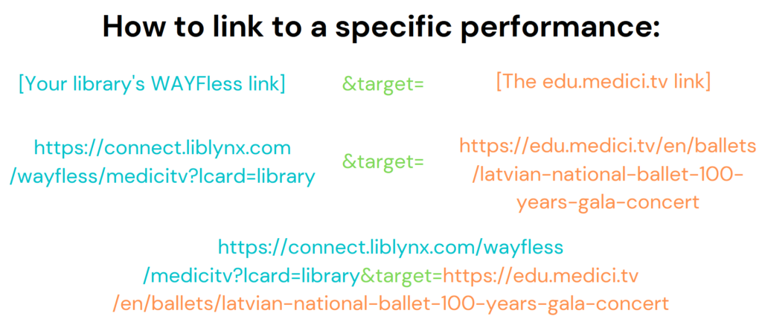

Live on the 24th December: Andreas Reize conducts Bach's Christmas Oratorio
  - https://edu.medici.tv/en/concerts/andreas-reize-conducts-bach-christmas-oratorio-gewandhausorchester-thomanerchor-leipzig
  - Broadcast date: Saturday, December 24, 2022 at 10:00 AM GMT
Bach's timeless, irresistible Christmas Oratorio returns to Leipzig—and to St. Thomas's Church, where several of its six gorgeous cantatas were heard for the very first time in 1734-35! Adding to the historical import of this unmissable event are the Gewandhausorchester, one of the world's oldest and most venerated orchestras founded in 1781, and the Thomanerchor (St. Thomas Choir of Leipzig), a legendary ensemble formed over eight hundred years ago in 1212 and directed by Bach himself between 1723 and 1750.
The eighteenth person to hold the post of Thomaskantor since Bach, Andreas Reize leads the impeccable orchestra and choir—joined by soloists Christina Landshamer, Benedikt Kristjánsson, and Konstantin Krimmel—in a festive and delightful performance of one of those cherished works from which the holiday spirit flows unfettered and ebullient.
Photo © Andreas Schlueter
Johann Sebastian Bach, Christmas Oratorio, BWV 248
Part I: For the First Day of Christmas
Part II: For the Second Day of Christmas (The Annunciation to the Shepherds)
Part III: For the Third Day of Christmas (The Adoration of the Shepherds)
Part IV: For New Year's Day (Feast of the Circumcision)
Part V: For the First Sunday of New Year (The Journey of the Magi)
Part VI: For the Feast of Epiphany (The Adoration of the Magi)
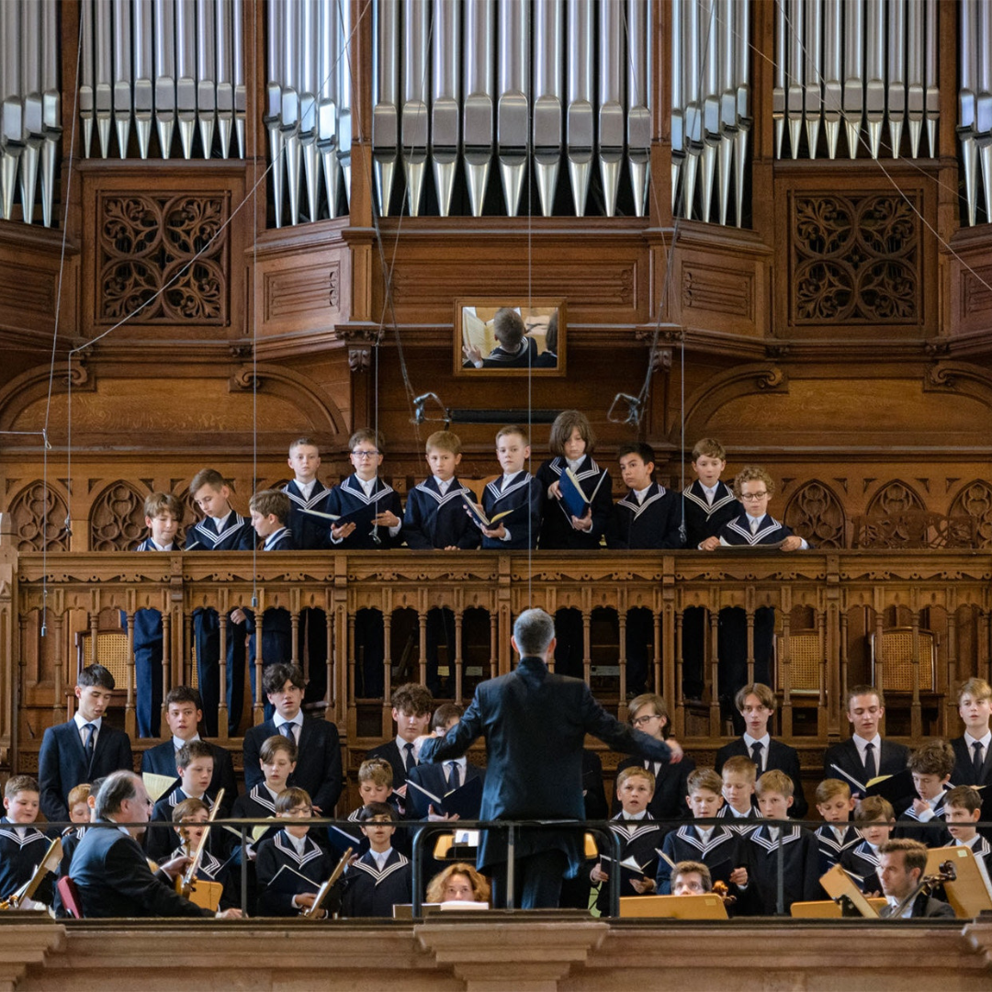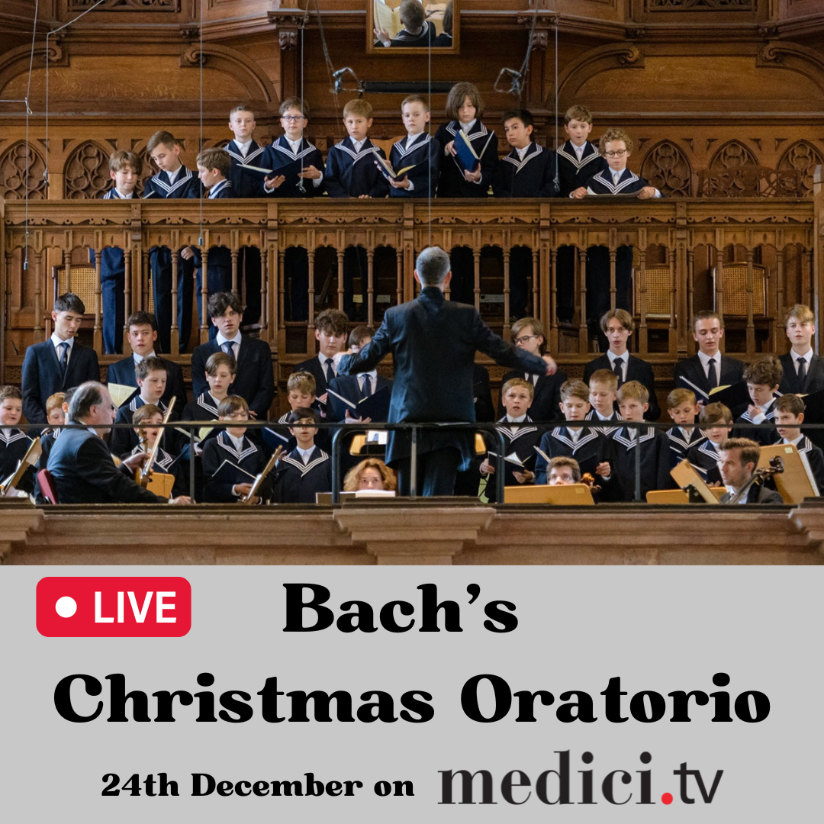

Live on Christmas Day: David Giménez conducts the Assisi Christmas Concert — With Katherine Jenkins
  - https://edu.medici.tv/en/concerts/david-gimenez-conducts-assisi-christmas-concert-katherine-jenkins-orchestra-della-rai
  - Broadcast date: Sunday, December 25, 2022 at 11:00 AM GMT
For a heartwarming Christmas concert that combines new and old holiday standards with impeccable classical selections in one of the world's most famous architectural masterpieces, look no further! You'd be hard-pressed to find a more stunning backdrop than the Basilica of Saint Francis of Assisi, a UNESCO World Heritage Site whose beloved Christmas concert returns for another memorable edition on medici.tv…
Led by Spanish conductor David Giménez, this year's festivities feature star Welsh singer Katherine Jenkins—a rare talent equally at home in classical and popular repertoire—as well as the prestigious RAI National Symphony Orchestra, the tremendous Turin-based Coro Maghini under Claudio Chiavazza, and stupendous solos with clarinetist Enrico Maria Baroni and violinist Alessandro Milani! Sing along with your favorites and enjoy this beautifully chosen program, the ideal soundtrack for yuletide warmth and holiday spirit.
Photo: Katherine Jenkins © David Venni
Program
Isaac Watts/Lowell Mason, Joy to the World
Antonín Dvořák, Slavonic Dances, Op. 46
No. 8 in G Minor (Furiant)
Adolphe Adam, O Holy Night
Wolfgang Amadeus Mozart, Ave verum corpus, K. 618
Traditional, Adeste fideles
Richard Strauss, Romance for Clarinet and Orchestra
Ariel Ramírez, Navidad Nuestra
3. El Nacimiento
Sergio Villar, ¡Ay, para Navidad!
Jules Massenet, "Méditation" from Thaïs
Johann Strauss II, Der Zigeunerbaron (The Gypsy Baron)
Overture
Paul Bateman, Christmas Medley
Franz Xaver Gruber, Silent Night
Felix Mendelssohn-Bartholdy, Hark! The Herald Angels Sing
